Attempted 14/03/20 pls dont judge xox

1a.

We need to show:

∀e+∈E+.B∪H⊧e+  (complete) and

∀e-∈E-.B∪H⊧e- (consistent)

For the positive example:

← smartLight(l1,b1,o1)

|

← switchLight(l1,o1), closeBlind(b1,o1)

|

← detectMovement(S,o1), closeBlind(b1,o1)

|

← closeBlind(b1,o1)

|

dark(o1)

|

□

For the negative examples:

← smartLight(l2,b2,o2)

|

← switchLight(l2,o2), closeBlind(b2,o2)

|

← detectMovement(S,o2), closeBlind(b2,o2)

|

← closeBlind(b2,o2)

|

dark(o2)

|

■

← smartLight(l3,b3,o3)

|

← switchLight(l3,o3), closeBlind(b3,o3)

|

← detectMovement(S,o3), closeBlind(b3,o3)

|

■

1b.

There is one positive example, so we have to do 1 iteration of the coverage loop

Step 1: Abductive

Pick a positive example e = smartLight(l1,b1,o1)

Abducibles are the ground modeh predicates

Solve abductive task <B, Ab, ∅>

← smartLight(l1,b1,o1)

|

← switchLight(l1,o1), closeBlind(b1,o1)

|  |  |
| --- | --- |
| |  | | --- | | ← not switchLight(l1,o1)  |  ■ | |

∆ = {switchLight(l1,o1)}

|

← closeBlind(b1,o1)

|

|  |  |
| --- | --- |
| |  | | --- | | ← not closeBlind(b1,o1)  |  ■ | |

∆ = {switchLight(l1,o1), closeBlind(b1,o1}

|

□

So ∆ = {switchLight(l1,o1), closeBlind(b1,o1}

Step 2: Deductive

We need to see which relevant modeb literals we can entail from B∪{not e}

B∪{not e} ⊢ { detectMovement(s1,o1), dark(o1) }

Step 3: Inductive

We can construct a ground kernel set:

switchLight(l1,o1) ← detectMovement(s1,o1), dark(o1)

closeBlind(b1,o1) ← detectMovement(s1, o1), dark(o1)

And can generalise this to get K

K = {

switchLight(L,O) ← detectMovement(S,O), dark(O)

closeBlind(B,O) ← detectMovement(S, O), dark(O)

}

Then we transform K:

T = {

switchLight(L,O) ← use(1,0), try(1,1,L,O)

try(1,1,L,O) ← not use(1,1)

try(1,1,L,O) ← use(1,1), detectMovement(S,O)

closeBlind(B,O) ← use(2,0), try(2,1,B,O)

try(2,1,B,O) ← not use(2,1)

try(2,1,L,O) ← use(2,1), dark(O)

}

And then perform the bductive proof of all the positive examples and all negated negative examples

<B∪T, Ab, IC>

Where:

Ab = {use(1,0), use(1,1), use(2,0), use(2,1), not use(1,0), not use(1,1), not use(2,0), not use(2,1)}

IC = {

← use(1,0), not use(1,0),

← use(1,1), not use(1,1),

← use(2,0), not use(2,0),

← use(2,1), not use(2,1),

}

I’m ngl this proof is long af and pretty obvious so someone else can fill it out if they want, it’s quite similar to the ones above :)

1c.

Progol5 can’t be used to compute H, since multiple rules are needed in H to prove a single positive example (which we showed above in HAIL).

We can see the set of contrapositives would include:

non_switchLight(L,O) ← non_smartLight(L,B,O), closeBlind(B,O)

non_closeBlind(B,O) ← non_smartLight(L,B,O), switchLight(L,O)

To show non_switchLight, we need closeBlind, which we don’t have, since there is an incomplete startset.

You should probably do an SLD proof starting with ← non_switchlight(l1,o1) and show it fails, but again it’s simple and i cba to write it out xx

2a.

No, T does not accept an inductive solution derivable by KSS.

We need to show citizen(john) and not citizen(tom).

Say we do this with age as the modeb. We can deduce age(john,18). So the rule would be citizen(X) ← age(x, 18). But this would also prove the negative example.

So the other alternative is to have naturalized as the modeb. We can’t deduce naturalized(john) since it relies on adult(john), which we don’t have.

Therefore there is no way we can derive a hypotheses which satisfies the task.

2bi.

First compute the abductive top theory TM:

TM = {

citizen(P) ← body([P],(m1,[ ],[ ]))

adult(P) ← body([P],(m2, [ ],[ ]))

body(ISF, RSF) ← rule(RSF)

body(ISF, RSF) ← naturalized(P), link([P], ISF, L), append(RSF, (m3, [], L), NR),

append(ISF, [], NI), body(NI, NR)

body(ISF, RSF) ← age(P,N), link([P], ISF, L), append(RSF, (m4, [N], L), NR),

append(ISF, [], NI), body(NI, NR)

}

Then perform abduction on <B∪TM, Ab, {}> of ← citizen(john), not citizen(tom)

Where Ab = {rule([(m1,[],[])]), rule([(m2,[],[])]) … }

**Insert proof here, again it’s simple and I’m lazy**

In the not citizen(tom) stage, do we have to go to the age(tom, N) step and then abduce the not rule part

as well as abducing the not rule([m_1, [], []))??

Just seems like so much to write out

apologies for bad handwriting:

Using j for John, c for citizen

Also i don't think we need to show not citizen(tom) as this proof just needs to show H is complete, meaning it covers the positive examples

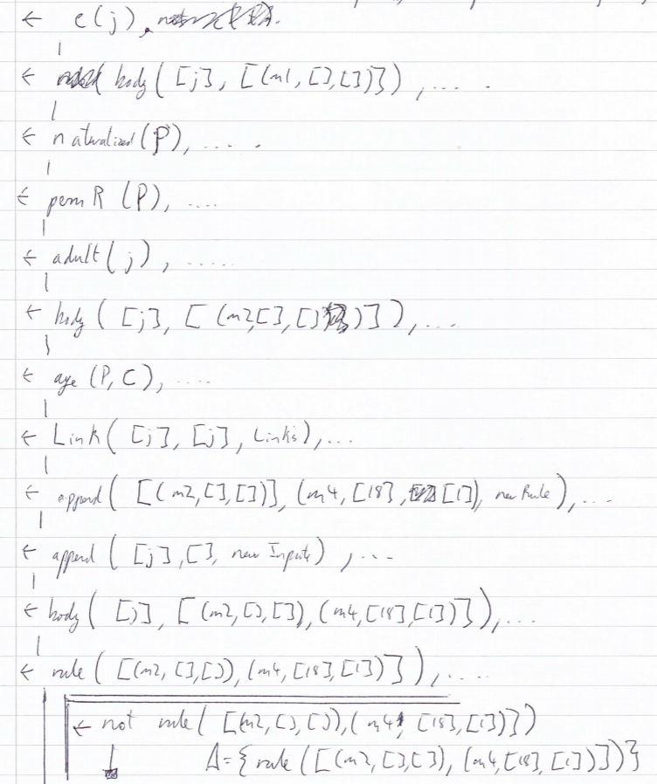

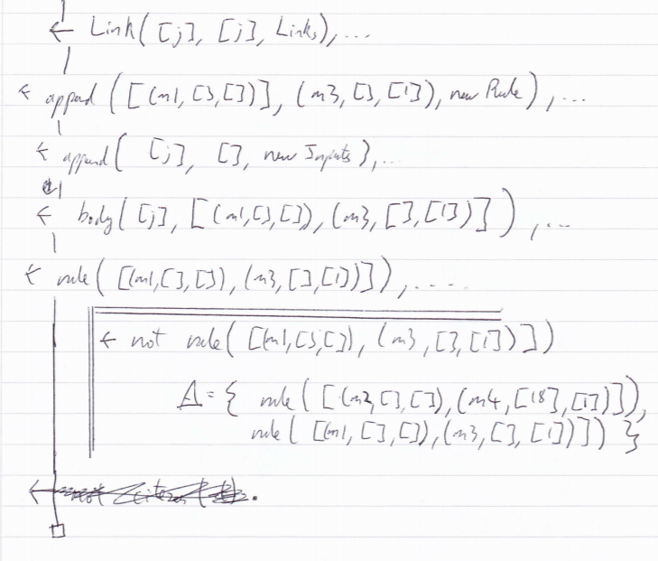

You end up with

∆ = {

rule([(m1, [], []), (m3, [], [1])]),

rule([(m2, [], []), (m4, [18], [1])])

}

Which translates to the hypothesis H

Since in the proof we show not citizen(tom), we know it satisfies none of the negative examples, and so is consistent

ALTERNATIVE

as i didn’t show not citizen(tom) in the proof, I showed H was consistent by showing

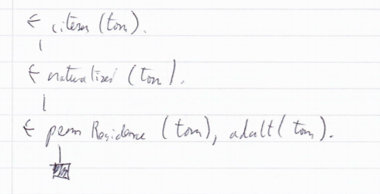

2bii.

T1 = citizen(P) ← $body(P)

T2 = adult(P) ← $body(P)

T3 = $body(P) ←

T4 = $body(P) ← naturalised(P), $body(P)

T5 = $body(P) ← age(P, X), nat(X), $body(P)

# with typing (also do we need typing for constants ??? Ale is not explicit about it)

T1 = citizen(P) ← $body(P), person(P)

T2 = adult(P) ← $body(P), person(P)

T3 = $body(P) ←

T4 = $body(P) ← naturalised(P), person(P), $body(P)

T5 = $body(P) ← age(P, X), nat(X), person(P), $body(P)

T = {Tn|1<=n<=5}

3ai.

F = {s(1,a), s(2,b), t1(1), t1(2), t2(a), t2(b), q(1), r(2)}

AS1 = F∪{p(1,2)}

AS2 = F∪{p(2,1)}

3aii.

There exists at least one answer set, in this case AS1, which entails all positive examples and does not entail any negative examples.

3bi.

q(T) :- t1(T).

q(T) :- t1(T), s(T, C).

q(T) :- t1(T), s(T, C), s(T, C2).

r(T) :- t1(T).

r(T) :- t1(T), s(T, C).

r(T) :- t1(T), s(T, C), s(T, C2).

3bii.

%Sk

q(T) :- t1(T), rule(1).

q(T) :- t1(T), s(T, C), rule(2,C).

q(T) :- t1(T), s(T, C), s(T, C2), rule(3,C,C2).

r(T) :- t1(T), rule(4).

r(T) :- t1(T), s(T, C), rule(5, C).

r(T) :- t1(T), s(T, C), s(T, C2), rule(6, C, C2).

%B

as in B

{rule(1), rule(2,a), rule(2,b), rule(3, a, b), rule(4), rule(5,a), rule(5,b), rule(6,a,b)}.

goal :- p(1,2), not p(2,1).

:- not goal.

#minimise[rule(1)=1, rule(2,C)=2, rule(3,C,C1)=3, rule(4)=1, rule(5,C)=2, rule(6,C,C1)=3].

3biii.

AS = {s(1,a), s(2,b), t1(1), t1(2), t2(a), t2(b), rule(2,a), rule(5,b), q(1), r(2), p(1,2), goal}

3ci.

AS1 = {heads.}

AS2 = {tails.}

3cii.

No, because if you had E+ = {tails}, then a more minimal H would be {tails}.

3ciii.

No, since the Answer Sets of B2∪H2 do not intersect, so there are no literals which occur in every answer set, so there are no positive or negative examples which can be given that occur in every answer set.

3civ.

E+ = {<{heads},∅>, <{tails},∅>}

E- = ∅

====

Alternative answer:

E+ = {<{heads}, ∅>, <{tails}, ∅>, <∅, {heads}>, <∅, {tails}>}

E- = {<{heads, tails}, ∅>}

Question 4 is unassessed?